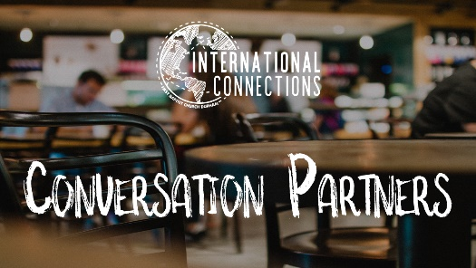

Topic:
Effective Communication

Reading Resource:
Why Communication is So Important for Leaders (Link)

Article Recommendation: Read through the article with your friend, correcting pronunciation errors and defining new words along the way. Don’t worry if you can’t get through the entire thing; encourage your friend to continue reading and bring questions next time!

Discussion Guide:
- What do you think makes someone an effective communicator? Why?
- What do you think are the most important things to remember in communicating? Why?
- The article discusses the importance of someone’s words and actions matching. In English, we often say you need to “talk the talk, walk the walk.” Why is this important?
- Who is an excellent communicator (both past or present) that you look up to? Why do you respect this leaders’ communication? Did they “talk the talk and walk the walk?”
- What do you think is the cause of bad communication? Why do you think people often struggle with it? What is the solution?

